

Lab Task No 1

Name : M Musa

Reg No : 41557

Submitted To : Mam Faiza Ali

Date : 29/10/26

PythonPractice:
Calculator:

Code:
a= int(input("Enter First No:")) b=int(input("EntersecondNo:"))
Operation=input("Whichfunctiondoyouwanttoperform(+,-,*,/:):")

defadd(a,b): returna+b
defsub(a,b): returna-b
defmul(a,b):
returna*b def div(a, b):
ifb==0:
return"Cannotdividebyzero"return a / b

matchOperation: case "+":
print(f"Sum:{add(a,b)}") case "-":
print(f"sub:{sub(a,b)}") case "*":
print(f"mul:{mul(a,b)}") case "/":
print(f"Div:{div(a,b)}")

Screenshot:

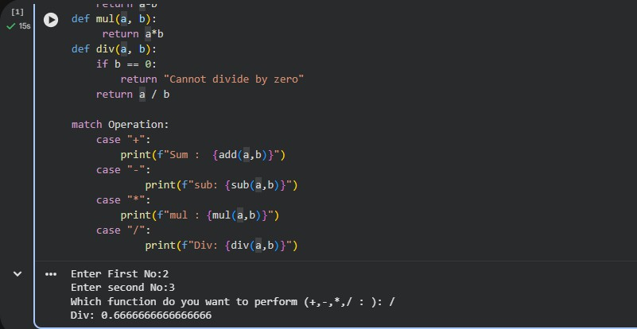

VacuumAgent:

def vacuum_agent(percept): location,status=percept if status == "Dirty":
return "Suck"eliflocation=="A":
return"Right"else:
return"Left"

#Environment
world={"A":"Dirty","B":"Dirty"} location = "A"

forstepinrange(6):
action=vacuum_agent((location,world[location]))
print(f"Step{step}:at{location},sees{world[location]},does{action}")

if action == "Suck": world[location]="Clean"
elifaction=="Right": location = "B"
elifaction=="Left": location = "A"

Screenshot:

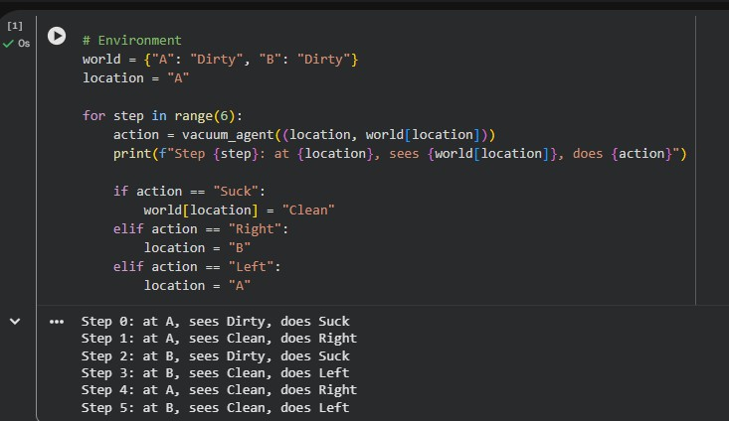

EnhancedVacuum Agent:
Code:

def vacuum_agent(percept): location,status=percept if status == "Dirty":
return "Suck"eliflocation=="A":
return"Right"else:
return"Left"

world={"A":"Clean","B":"Dirty"} location = "A"
score=0

forstepinrange(10):
if "Dirty"not in world.values(): print("Allroomsclean.Stopping.") break

action=vacuum_agent((location,world[location]))
print(f"Step{step}:at{location},sees{world[location]},does{action}")

if action == "Suck": world[location]="Clean"score += 10
elifaction=="Right": location = "B"score -= 1
elifaction=="Left": location = "A"score -= 1

print(f"Finalscore:{score}")

Screenshot:

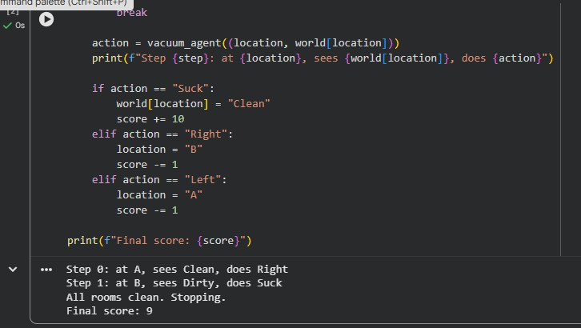

Get hub link: https://github.com/malikmusa044/Ai-Lab-Task-no-1.git

